


A Periodical Review Issued by Statistics Department
Issue No. 10/2025 Reporting Period: 01- 31/10/2025

- Monetary Indicators: -
(SDG Million)
Period  Indicator | Dec.  2023* | Dec.  2024* | Sep.  2025* | Oct.  2025*
Broad Money M2 (2+1) | 7,595,400 | 14,480,589 | 21,697,317 | 22,636,618
Growth Rate of M2 (%) | 54.1 | 90.6 | 49.8 | 56.3
1. Narrow Money M1 (A+B) | 3,355,549 | 4,808,127 | 7,891,516 | 7,955,219
A. Currency with the public | 1,729,492 | 1,614,730 | 2,759,450 | 2,890,185
Currency with public/ broad money (%) | 22.8 | 11.2 | 12.7 | 12.8
B. Demand Deposits | 1,626,057 | 3,193,397 | 5,132,066 | 5,065,033.6
Demand deposits/ broad money (%) | 21.4 | 22.1 | 23.7 | 22.4
2. Quasi Money | 4,239,851 | 9,672,462 | 13,805,801 | 14,681,399
Quasi money/ broad money (%) | 55.8 | 66.8 | 63.6 | 64.9
Banks Total Assets/Liabilities | 8,742,377 | 18,359,669 | 29,769,881 | 31,442,160
Banks Total Finance | 2,419,947 | 3,683,577 | 5,071,601 | 5,243,114
Banks Total Deposits | 5,275,328 | 11,653,303 | 17,014,891 | 18,115,053
Banks total finance/ deposits (%) | 45.9 | 31.6 | 29.8 | 28.9
Provisional Data*

Website: www.cbos.gov.sd
Email: publications@cbos.gov.sd

(2) Liquidity Position During (December 2023- October 2025) *:

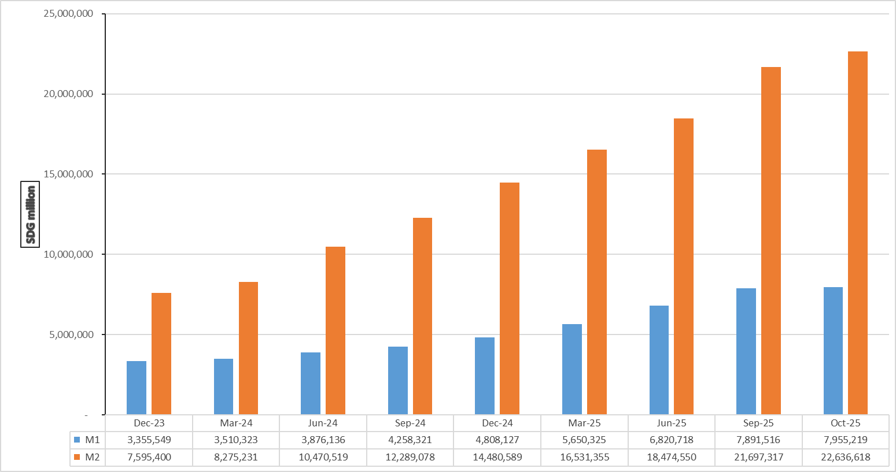

Provisional Data*

(3) Banks Deposits*:
(SDG Million)
Particular  Deposits | 30/09/2025** |  | 31/10/2025** |  | %Change
Particular  Deposits | Local | Foreign | Local | Foreign | Local | Foreign
Demand | 3,853,195.4 | 1,436,416.6 | 4,011,211 | 1,490,075.4 | 4.1 | 3.7
Savings | 7,091,774.4 | 193,777 | 7,792,071.7 | 214,313.2 | 9.9 | 10.6
Investment | 527,617.4 | 1,239,168.2 | 548,290.8 | 1,250,379.1 | 3.9 | 0.9
Margins on LCs& LGs | 11,721.1 | 216,458.7 | 11,859.2 | 243,093.0 | 1.2 | 12.3
Others | 2,707.2 | 4,019.7 | 3,601.4 | 3,896.0 | 33 | (3.1)
Total | 11,487,015.4 | 3,089,840.2 | 12,367,034.1 | 3,201,756.8 | 7.7 | 3.6
Total | 14,576,855.6 |  | 15,568,790.9 |  | 6.8
* Deposits of Residents &Non-residents.
** Provisional Data.

(4) Stock of Banks Finance in Local Currency at the end of September 2025:

- Cost of Finance:

      - Murabaha weighted average profit margins amounted to 19.7% and Musharaka weighted average was 12.9%.
      - Murabaha profit margins ranged between Maximum margin 42% and Minimum margin 2%
      - Musharaka shares ranged between Maximum rate 75% and Minimum rate 3%

- Flow and Stock of Banks Finance in Local Currency by Sectors at the end of October 2025

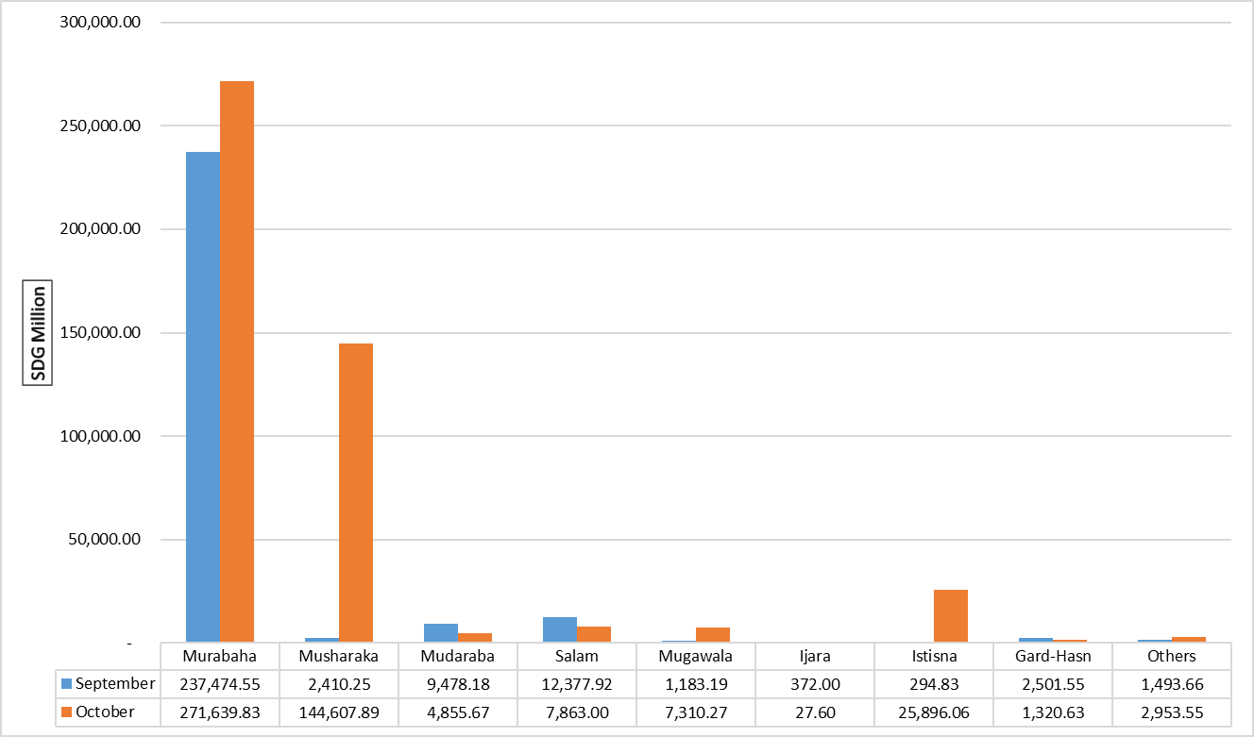

Bank financing balances in local currency by sector as of the end of October 2025
Sector | Flow* | Share % | Balance* | Share (%)
Agriculture | 115,404.35 | 24.74 | 1,152,768.4 | 26.59
Industry | 101,039.11 | 21.66 | 909,649.5 | 20.98
Transport &Storage | 5,569.35 | 1.19 | 211,543.3 | 4.88
Local Trade | 2,483.15 | 0.53 | 206,562.5 | 4.76
Exports | 25,985.36 | 5.57 | 407,155.7 | 9.39
Imports | 24,327.35 | 5.22 | 249,128.1 | 5.75
Construction | 7,298.69 | 1.56 | 85,382.0 | 1.97
Energy &Mining | 145,408.50 | 31.17 | 286,278.0 | 6.60
Nonbank Financial Institutions | 0.00 | 0.00 | 286,278.0 | 6.60
State &Local Govt. | 0.00 | 0.00 | 8,584.3 | 0.20
Others | 38,958.65 | 8.35 | 532,359.2 | 12.28
Total | 466,474.50 | 100.0 | 4,335,89.21 | 100.0
(SDG Million)

* Provisional data

(5) Inflation Rate:
Inflation rate Decreased from 83.5% at the end of September 2025 to 77.4% at the end of October 2025.
The Inflation Rates at the end of Month (December 2023 - October 2025)
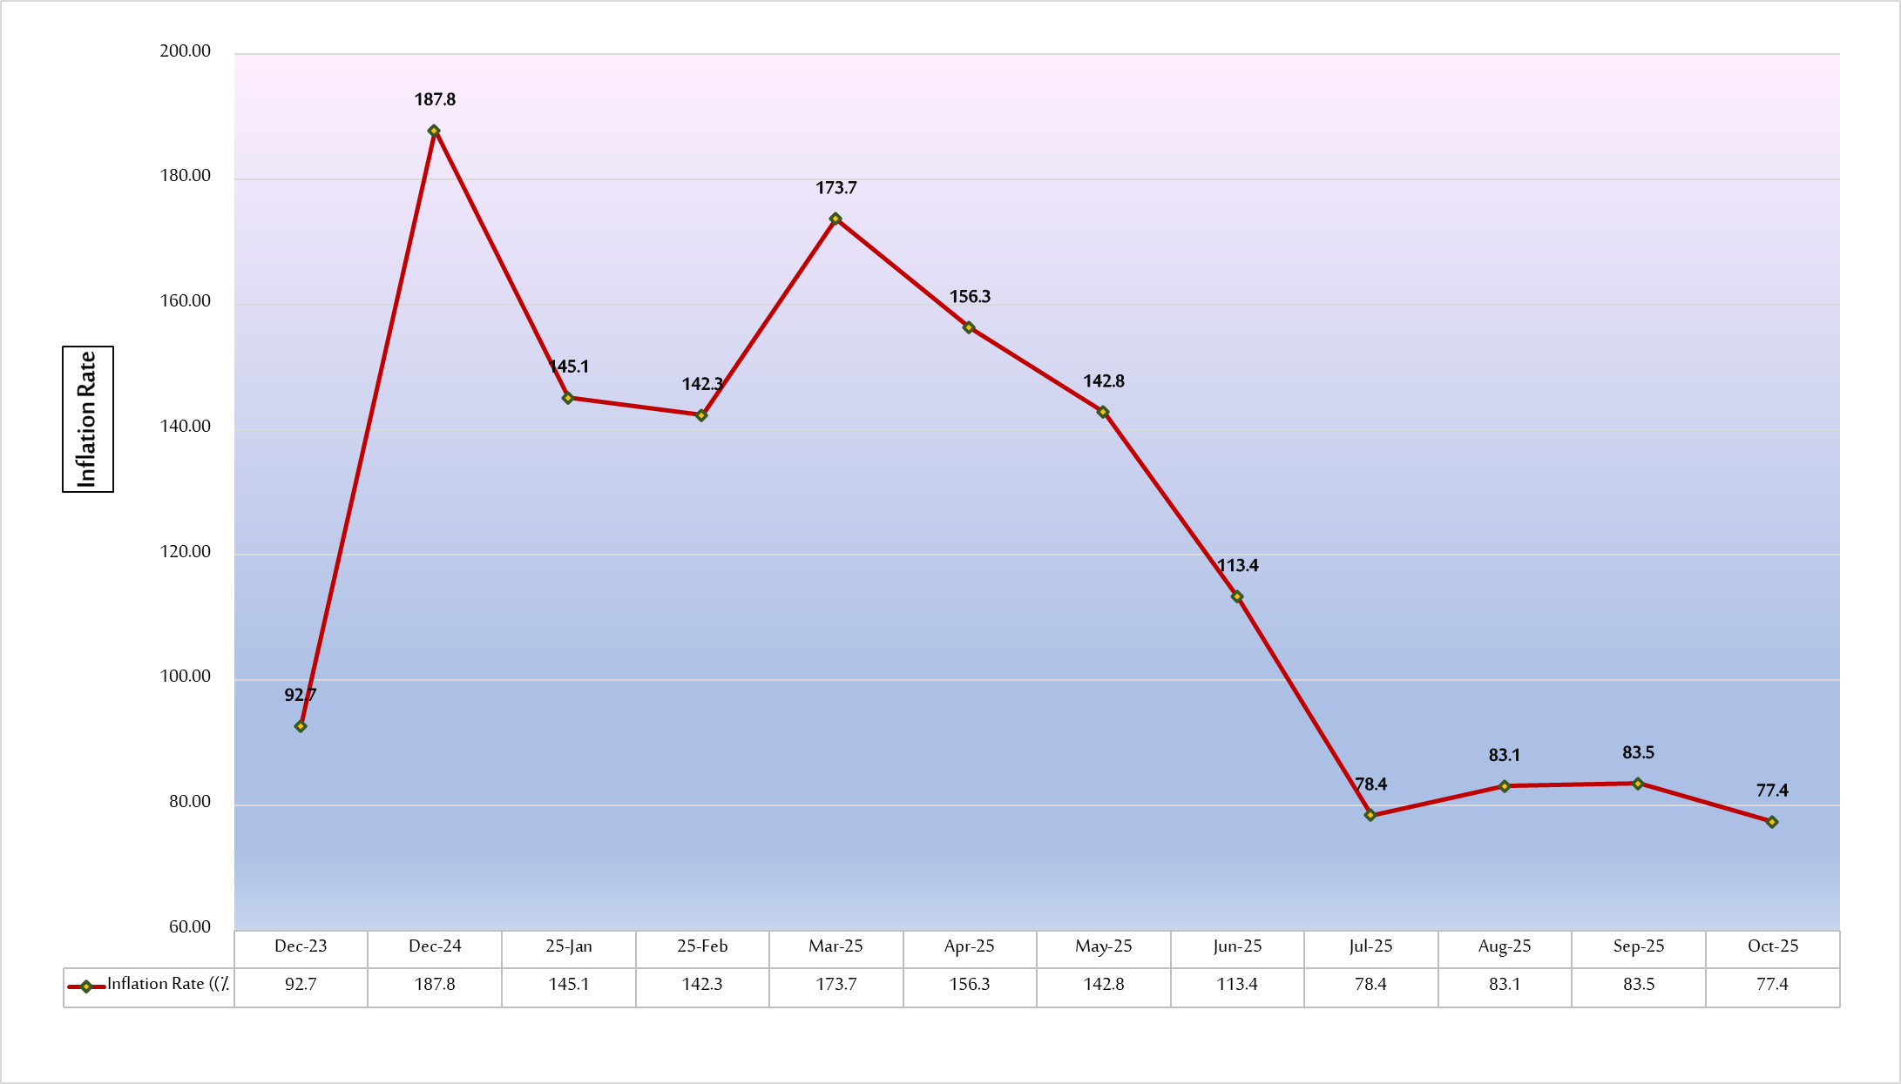

(6) Exchange Rate:
The average exchange rate of USD against the Sudanese Pound at the Commercial Banks and Exchange Bureaus as of 31th October 2025.
(SDG/USD)
Rates  Particular | 30/09/2025 |  | 31/10/2025 |  | %Change
Rates  Particular | Buying Rate | Selling Rate | Buying Rate | Selling Rate | Buying Rate | Selling Rate
Commercial Banks | 2,564.48 | 2,583.08 | 2,561.90 | 2,606.98 | 25.50 | 27.59
Exchange Bureaus | 3,200.19 | 3,037.47 | 3,250.09 | 3,299.77 | 35.23 | 35.61

(7) Balance of Payments:
(USD Millions)
Period  Particular | 2022 | 2023 | 2024* | Jan. – Jun.  2025
A- Current Account (1+2+3) | (4,443.1) | (2,347.0) | (3,924.9) | (2,111.6)
1. Balance on Goods &Services (i+ii) | (5,667.0) | (4,466.9) | (2,410.3) | (1,464.2)
i. Balance on Trade in Goods | (5,628.0) | (3,120.3) | (1,285.6) | (1,022.7)
- Exports | 4,357.4 | 3,628.4 | 3,134.5 | 1,354.9
- Imports | 9,985.4 | 6,748.7 | 4,420.1 | 2,377.6
ii. Balance on Trade in Services | (39.0) | (1,346.6) | (1,124.8) | (441.6)
- Receipts | 1,550.7 | 25.3 | 246.2 | 114.2
- Payments | 1,589.7 | 1,371.9 | 1,371.0 | 555.7
2. Balance on Primary Income (Income) | (1,078.5) | 187.0 | (1,584.5) | (741.3)
3. Balance on Secondary Income (Current Transfers) | 2,302.4 | 1,932.9 | 69.9 | 93.8
B- Capital Account | 112.9 | 0.0 | 0.0 | 0.0
C- Financial Account  of which:  Reserve Assets | (3,791.0)  (146.7) | (460.9)  (116.9) | (2,491.5)  (1.5) | (1,818.7)  1.5
Net Errors &Omissions | 539.2 | 1,886.1 | 1,433.4 | 293.0
* Provisional Data
Note: The BOPs items were reviewed based on the balance of payments and international investment position manual sixth edition (BPM6-2009).

