


A Periodical Review Issued by Statistics Department
Issue No. 12/2025 Reporting Period: 01- 31/12/2025

- Monetary Indicators: -
(SDG Million)
Period  Indicator | Dec.  2023* | Dec.  2024* | Nov.  2025* | Dec.  2025*
Broad Money M2 (2+1) | 7,595,400 | 14,480,589 | 24,841,937 | 25,303,078
Growth Rate of M2 (%) | 54.1 | 90.6 | 71.6 | 74.7
1. Narrow Money M1 (A+B) | 3,355,549 | 4,808,127 | 8,733,667 | 8,828,027
A. Currency with the public | 1,729,492 | 1,614,730 | 3,052,074 | 3,220,492
Currency with public/ broad money (%) | 22.8 | 11.2 | 12.3 | 12.7
B. Demand Deposits | 1,626,057 | 3,193,397 | 5,681,594 | 5,607,535
Demand deposits/ broad money (%) | 21.4 | 22.1 | 22.9 | 22.2
2. Quasi Money | 4,239,851 | 9,672,462 | 16,108,270 | 16,475,051
Quasi money/ broad money (%) | 55.8 | 66.8 | 64.8 | 65.1
Banks Total Assets/Liabilities | 8,742,377 | 18,359,669 | 34,398,263 | 34,838,131
Banks Total Finance | 2,419,947 | 3,683,577 | 5,510,283 | 5,606,392
Banks Total Deposits | 5,275,328 | 11,653,303 | 19,707,364 | 20,494,142
Banks total finance/ deposits (%) | 45.9 | 31.6 | 28.0 | 27.4
Provisional Data*

Website: www.cbos.gov.sd
Email: publications@cbos.gov.sd

(2) Liquidity Position During (December 2023- December 2025) *:

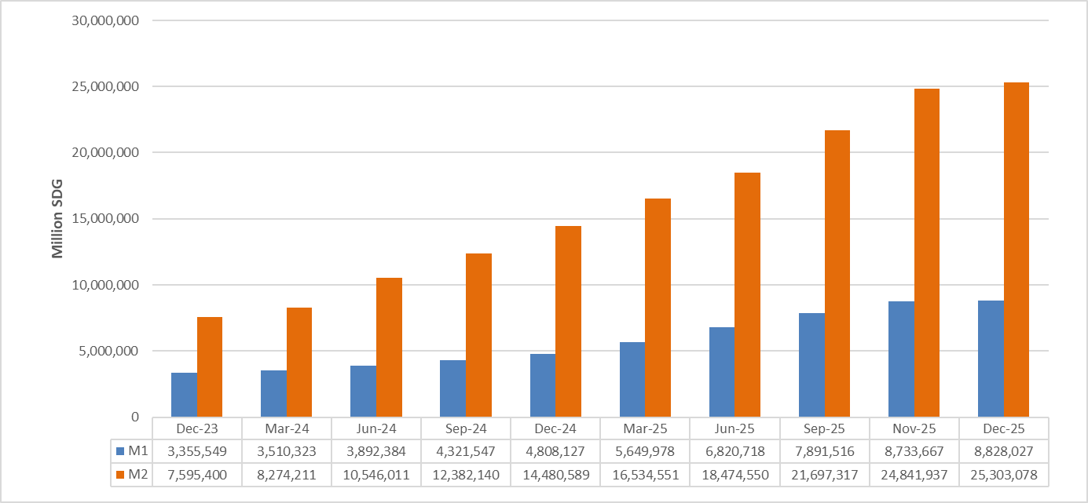
Provisional Data*

(3) Banks Deposits*:
(SDG Million)
Particular  Deposits | 30/11/2025** |  | 31/12/2025** |  | %Change
Particular  Deposits | Local | Foreign | Local | Foreign | Local | Foreign
Demand | 4,675,439.2 | 3,775,736.2 | 4,741,426.0 | 3,253,031.4 | 1.4 | (13.8)
Savings | 8,366,421.5 | 475,713.1 | 9,228,836.9 | 436,353.7 | 10.3 | (8.3)
Investment | 622,276.2 | 1,488,138.0 | 661,770.9 | 1,391,132.5 | 6.3 | (6.5)
Margins on LCs& LGs | 24,019.5 | 268,379.9 | 22,559.3 | 266,457.0 | (6.1) | (0.7)
Others | 4,184.5 | 8,883.8 | 4,039.4 | 7,303.0 | (3.5) | (17.8)
Total | 13,692,341.0 | 6,016,851.0 | 14,658,632.6 | 5,354,277.6 | 7.1 | (11.0)
Total | 19,709,192.0 |  | 20,012,910.1 |  | 1.5
* Deposits of Residents &Non-residents.
** Provisional Data.

(4 Banks Finance in Local Currency at the end of December during (01- 31/ Dec/ 2025):
- Cost of finance:
      - Murabaha weighted average profit margins amounted to 25٪ and Musharaka weighted average was 22.3٪
      - Murabaha profit margins ranged between Maximum margin 28٪ and Minimum margin 2.5%
      - Musharaka shares ranged between Maximum rate 75% and Minimum rate 10%

- Flow of Commercial Banks Finance by Modes of Finance during (November 2025- December 2025)

SDG Millions
Percentage (%) | December 2025 | Percentage (%) | November 2025 | Modes
70.4 | 563,347.8 | 80.4 | 313,455.2 | Murabaha
9.4 | 75,186.8 | 0.7 | 2,617.5 | Musharaka
0.5 | 3,941.0 | 1.3 | 5,193.9 | Mudaraba
5.5 | 43,651.5 | 4.4 | 17,092.3 | Salam
2.1 | 16,704.1 | 0.3 | 1,176.9 | Mugawala
0.0 | 115.7 | 0.0 | 115.4 | Ijara
1.0 | 7,836.8 | 6.8 | 26,515.8 | Istisna
0.9 | 6,864.1 | 1.0 | 4,000.6 | Gard-Hasn
10.3 | 82,405.9 | 5.1 | 19,795.7 | Others
100 | 800,053.8 | 100 | 389,963.3 | Total

- Bank financing balances in local currency by sector as the end of December 2025
(SDG Million)
Sector | Balance* | Percentage (%) | Flow | Percentage (%)
Agriculture | 1,324,805 | 29.2 | 118,444 | 14.8
Industry | 1,051,005 | 23.2 | 345,509 | 43.2
Transport &Storage | 213,874 | 4.7 | 19,442 | 2.4
Local Trade | 368,734 | 8.1 | 6,725 | 0.8
Exports | 437,119 | 9.6 | 133,372 | 16.7
Imports | 161,906 | 3.6 | 33,630 | 4.2
Construction | 85,819 | 1.9 | 1,500 | 0.1
Energy &Mining | 210,237 | 4.6 | 10,545 | 1.3
Nonbank Financial Institutions | 29,603 | 0.7 | 0 | 0.0
State &Local Govt. | 8,584 | 0.2 | 0 | 0.0
Others | 639,049 | 14.1 | 130,887 | 16.4
Total | 4,530,734 | 100 | 800,054 | 100

*Provisional data
(5) Inflation Rate:
Inflation rate Decreased from 74.0 % at the end of November 2025 to 68% at the end of December 2025.

The Inflation Rates at the End of (December 2023 - December 2025)
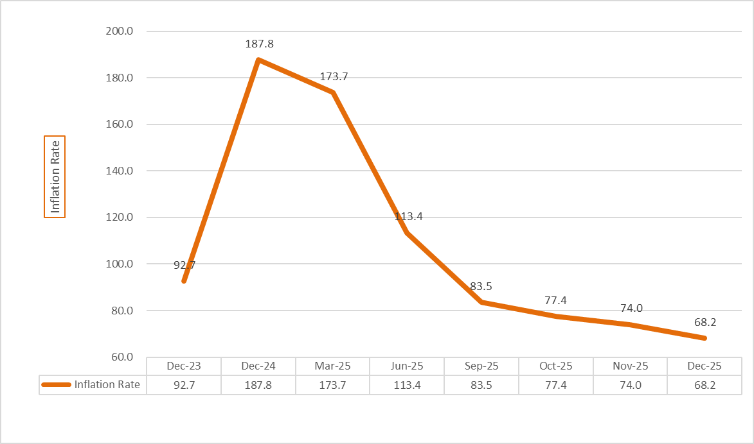

(6) Exchange Rate:
The average exchange rate of USD against the Sudanese Pound at the Commercial Banks and Exchange Bureaus as of 31st December 2025.
(SDG/USD)
Rates  Particular | 30/11/2025 |  | 31/12/2025 |  | %Change
Rates  Particular | Buying Rate | Selling Rate | Buying Rate | Selling Rate | Buying Rate | Selling Rate
Commercial Banks | 2,526.72 | 2,549.31 | 2,574.05 | 2,611.26 | 1.87 | 2.43
Exchange Bureaus | 3,273.69 | 3,312.69 | 3,254.35 | 3,294.77 | (0.59) | (0.54)

(7) Balance of Payments:
(USD Millions)
Period  Particular | 2022 | 2023 | 2024* | Jan. – Jun.  2025
A- Current Account (1+2+3) | (4,443.1) | (2,347.0) | (3,924.9) | (2,111.6)
1. Balance on Goods &Services (i+ii) | (5,667.0) | (4,466.9) | (2,410.3) | (1,464.2)
i. Balance on Trade in Goods | (5,628.0) | (3,120.3) | (1,285.6) | (1,022.7)
- Exports | 4,357.4 | 3,628.4 | 3,134.5 | 1,354.9
- Imports | 9,985.4 | 6,748.7 | 4,420.1 | 2,377.6
ii. Balance on Trade in Services | (39.0) | (1,346.6) | (1,124.8) | (441.6)
- Receipts | 1,550.7 | 25.3 | 246.2 | 114.2
- Payments | 1,589.7 | 1,371.9 | 1,371.0 | 555.7
2. Balance on Primary Income (Income) | (1,078.5) | 187.0 | (1,584.5) | (741.3)
3. Balance on Secondary Income (Current Transfers) | 2,302.4 | 1,932.9 | 69.9 | 93.8
B- Capital Account | 112.9 | 0.0 | 0.0 | 0.0
C- Financial Account  of which:  Reserve Assets | (3,791.0)  (146.7) | (460.9)  (116.9) | (2,491.5)  (1.5) | (1,818.7)  1.5
Net Errors &Omissions | 539.2 | 1,886.1 | 1,433.4 | 293.0
* Provisional Data
Note: The BOPs items were reviewed based on the balance of payments and international investment position manual sixth edition (BPM6-2009).

